
COMPUTING: PROGRAMMING- Variables in Games
KNOWLEDGE ORGANISER
Y6

Overview |  |  | More Complex Variables
Variables in Games  - Programming is when we make and input a set of instructions for computers to follow.  -Variables are changeable elements of a program. Scratch is one app in which we can explore variables.  -We use algorithms which we can plan, model, trial and debug, in order to create accurate command sequences, that enable variables to be enacted in games.  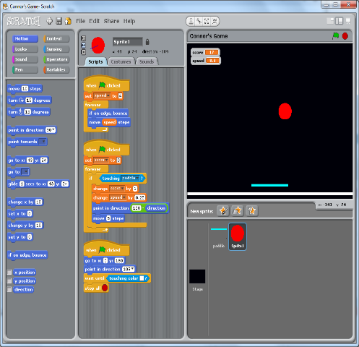 |  |  | - Variables should always have a value and an appropriate name.    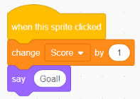  -Adding Callouts: Select ‘Looks’ from the menu on the left. Add it to the variable program. Edit the text to change the callout.        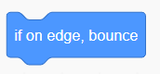  -Adding Motion: Many games require sprites to change position. This is achieved using the ‘Motion’ commands. Select ‘Motion’ from the menu on the left. Choose from the available motion commands.  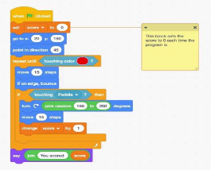  -Adding Motion: Many games require sprites to change position. This is achieved using the ‘Motion’ commands. Select ‘Motion’ from the menu on the left. Choose from the available motion commands  -Adding Comments: Comments are a good way of showing that you understand what your code is doing. Right click on the block that you want to comment on, and add in your comment.
Basic Variables
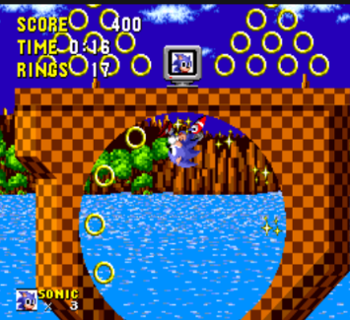
-Variables: A variable is something that is changeable. A variable can be set and changed throughout the running of a program.

In computer programming we use variables to store information that might change and can be used later in our program. E.g. in a game a variable could be the current score of the player; we would add 1 to the variable whenever the player gained a point.
 |  |  | Sequencing and Algorithms | Trialling and Debugging
 |  |  | 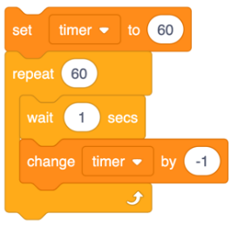  -A sequence is a pattern or process in which one thing follows another.  -We design algorithms (sets of instructions for performing a task) to help us program sequences involving multiple output devices (e.g. LEDs and motors).  -Programming is the process of keying in the code recognized by the computer into the software (using your algorithm). |   -Programmers do not put their computer programs straight to work. They trial them first to find any errors:  -Sequence errors: An instruction in the sequence is wrong or in the wrong place.  -Keying errors: Typing in the wrong code.  -Logical errors: Mistakes in plan/thinking.  -If your algorithm does not work correctly the first time, remember to debug it.
Making Variables in Scratch – The Basics


-Select ‘Variables’ (dark orange circle) from the menu on the left. Either choose from the available variables or ‘Make A Variable.’


-Select ‘Events’ (light orange circle) from the menu on the left.
Choose what needs to happen for the variable to change. E.g. ‘When this sprite clicked’ or ‘when space key pressed.’

-Select ‘Variables’ again from the menu on the left. Choose what will happen when the event happens, e.g. ‘change score by 1’ (to add a point) or ‘change score by -1’ to remove a point.
Important Vocabulary

Variable Change Name Value Set Design Event Code Task Test Motion Callout

