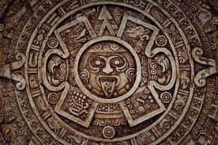
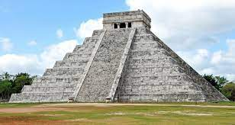
This term, our theme is “The Ancient Maya”.
The children will be required to complete a piece of work. It may be that your child decides to complete one or more activities from the list below or create their own piece of topic homework based on the theme.
We ask that the children continue to present their work as neatly as possible.
Our home learning will be shared the week commencing Monday 23 June 2025
Good luck everyone. We hope you enjoy the challenges.
- Create a Maya-inspired feast at home and present your tasting session to the class via a menu and photos of you preparing and eating the food
- Create a booklet of Maya-inspired fashion designs (masks, hats, dress)
- Write a non-fiction booklet about the Maya (including the key features of a piece of non-fiction writing – front cover, contents, pictures, blurb)
- Create your own Maya pyramid with your choice of building materials
- Design and create your own chocolate, inspired by our trip to Cadbury World
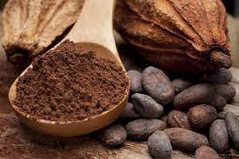
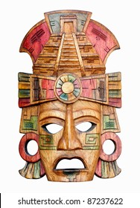
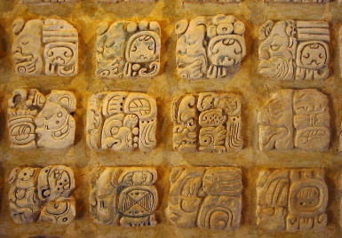
- Learning Extension: Can you think of any more activities based on our topic that you could share with the class?

