Year 1 Spring Newsletter 2026


Welcome back
We hope you all had a lovely Christmas and New Year, thank you for all the lovely gifts we received for Christmas, they aren’t expected and were very much appreciated.
The children have come back to school settled and recharged, they’ve all had a brilliant first week back
We are looking forward to an exciting term – if you ever have any concerns or queries, do not hesitate speak to us on the gate in the morning or at the end of the school day. You can also contact us via email or class dojo.

Miss Parry: parry.e1@welearn365.com
Mrs Carr: carr.s@welearn365.com

Year one team:

1-CM: Mrs Carr (Monday-Thursday). Mrs Moore (Friday)
1P: Miss Parry
Teaching assistants: Miss Fleming
Miss Johnson: Tuesday and Wednesday mornings
Miss Morris 1:1

Reading books

All children are grouped for guided reading, these groups change regularly to ensure your child is reading books at the correct level for them. Guided reading happens twice weekly. Some children also have extra 1:1 reading each week. Your child will usually have 1 book they are familiar with and one new book (both books focus on the same sounds and are on the same level).
Please send your child’s reading books and reading diary in every day. Please also remember to fill out their reading diaries each time you listen to them read, this is a very important record for us to have at school

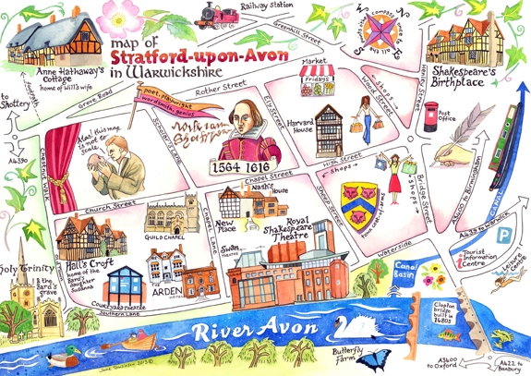

Volunteer Helpers
As always, we are grateful for any adult support within school. If you could spare any time at all, or know a Grandparent or someone who could, we would be extremely thankful for the help. Children love reading to an adult.

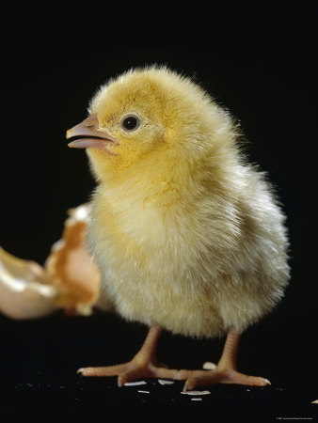

Home Learning

It’s really important that you listen to your child read as often as you can. Each child also has a Bug Club login in their reading diary, we usually allocate more games every other week, please speak to use if you have any problems with this.

PE
Our PE days this term are Wednesdays and Thursdays.

Children are to come to school in school PE kit
Children should be wearing black joggers or shorts, a white t-shirt and their red school jumper or a plain black hoody.
Please do not send you child in the home clothes (non-uniform) or anything with branding. Children also need trainers, no plimsoles or pumps please.

Thanks for your support with this.

Dates for your diary

Thursday 29th January at 9:00. Phonics Screening Check information session, infant hall with Mrs Carr.

Thursday 6th February 2:00pm
Tiger Tea Party (more information to follow):

The Gate:
Teachers are on the gate in the morning to welcome the children into school and to take quick messages. If you have any other concerns, or need a longer chat with teachers, please contact us to arrange a meeting.
Ensure you’re being respectful when speaking to any member of staff.
Thankyou
FOUNDATION SUBJECTS
In History, we will be
- Comparing toys in the past with the toys of today

In Geography, we will be learning about
- The weather and the seasons in the UK
In Art we will be:
- Creating 3D sculptures

In Music we will be
- Using our bodies to make music
- Moving our bodies to music
- Learning about the different features of a piece of music
- Learning a song

In DT we will be
- Joining fabrics to make a puppet

In PSHE we will be learning about
- Our dreams and goals
- How to keeping our bodies healthy

In Science we will be learning about
- The 5 senses
- Weather and Seasons

Remember:
Children need to be in full uniform every day, and PE uniform on PE days. Please ensure all jumpers and cardigans are clearly labeled. We also ask that long hair is tied up and only stud earrings are worn.
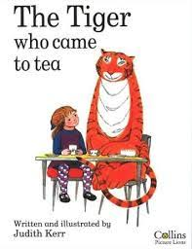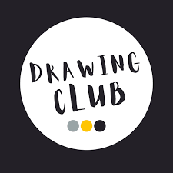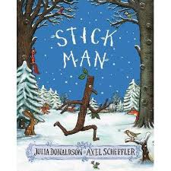
ENGLISH
We will be:
* Writing sentences which make sense, using capital letters, full stops and finger spaces.
*Reading and Spelling Common Exception Words. A list of the Year 1 word will be sent home with your child’s reading book
* Learning about adjectives and using them in our speaking and writing.
* Forming letters correctly, sitting them on the line and making sure they are the correct height.
* Retelling and creating our own stories, parts of a story
* Reading stories, poems, non-fiction, rhymes, chants.
* We use Drawing Club and Talk 4 writing lessons to develop children’s writing skills
PHONICS
Children are put in to phonics groups based on which phase they are currently working in. Mrs Carr/Mrs Moore and Mrs Beard will be taking the phase2-3 group, Mrs Mann will be taking the phase 3 Phonics group and Miss Parry and Miss Fleming will both be taking phase 5 phonics groups. Updates about what each of these groups are learning about will be put on class dojo, any questions, please ask.
MATHS
Working with numbers up to 50
Counting, place value, addition and subtraction within 20, then within 50
Counting backwards and forwards starting at different numbers.
Using symbols <,> and = to compare numbers.
Height and length &Mass and Volume
Skip counting in 2’s, 5’s and 10’s

PSHE
‘Being me in my world’.
• Feeling safe and special
• Being part of a class
• Understanding consequences

Phonics

