Year 1 Autumn Newsletter 2025


Welcome back
Welcome back to all of our families, we hope you had a lovely summer and the children are rested and recharged for a long term!
We are looking forward to an exciting term – if you ever have any concerns or queries, do not hesitate speak to us on the gate in the morning or at the end of the school day. You can also contact us via email or class dojo.

Miss Parry: parry.e1@welearn365.com
Mrs Carr: carr.s@welearn365.com

Year one team:

1-CM: Mrs Carr (Monday-Thursday). Mrs Moore (Fridays)
1P: Miss Parry
*Mrs Moore will also be covering 1P and 1CM for teachers planning time.

Teaching assistants: Miss Fleming, Miss Steventon and Miss Morris (1:1)

Reading books

There have been some small tweaks in how we operate reading in in year 1 this year. Reading Books will be changed once a week and each child will bring home two reading books. One book will be a book they have already read in school with an adult and one book will be a new book on the same level focusing on the same sounds. We will go into this in more detail at our parent information sessions.
Please ensure you listen to your child read 3 times a week, as per our homework policy and fill in their reading diaries.

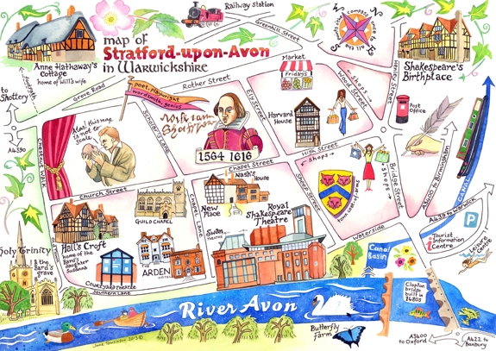

Volunteer Helpers
As always, we are grateful for any adult support within school. If you could spare any time at all, or know a Grandparent or someone who could, we would be extremely thankful for the help. Children love reading to an adult.

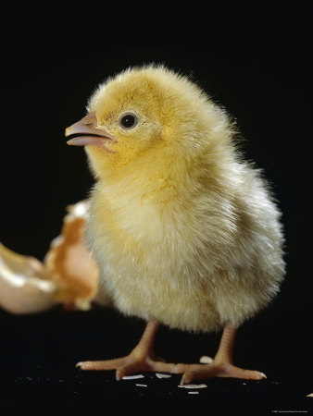

Home Learning

More information on this to follow.

PE/Outdoor learning
PE with a sports coach will be on Wednesdays and PE/Outdoor Learning (weather dependent) for class teachers will be Thursdays.

Children are to come to school in school PE kit both days.
Children should be wearing black joggers or shorts, a white t-shirt and their red school jumper (black hoodies are ok only if they are completely plain).
Please do not send you child in the home clothes (non-uniform) or anything with branding. Children also need trainers, no plimsolls or pumps please.
Please don’t worry about wellies, we will access the outdoor learning space on dry days this term.

Thanks for your support with this.

Dates for your diary
Please see the school and class Dojo for key dates.
Thank you for signing up for Dojo! If you don’t have a log in please speak to a member of the office staff.
Many thanks,
Year One Team


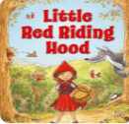
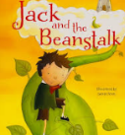
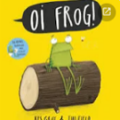
FOUNDATION SUBJECTS
History:
• Developing an understanding of personal
chronology
• Comparing childhoods from the past today

Geography,
• Learning abut where we live and our local area
• Creating simple maps

In Art we will be:
• Be mixing secondary colours
• Identifying primary colours
• Creating art with primary and secondary colours

In Music we will be
• Using our bodies to make music
• Moving our bodies to music
• Learning about the different features of a piece of music
• Leaning a song

In DT we will be
• Following a design structure to create windmills
• Completing various craft activities linked to our learning

In ICT & Computing we will be learning to:
• Using the Ipads to take photos and uploading them to our Dojo Portfolio
- Learning how to login to a laptop

In Science we will be learning about
• weather and seasons
• Materials

ENGLISH
We will be:
* Writing sentences which make sense, using capital letters, full stops and finger spaces.
*Spelling Common Exception Words. A list of the Year 1 word will be sent home with your child’s reading book
* Learning about adjectives and using them in our speaking and writing.
* Forming letters correctly, sitting them on the line and making sure they are the correct height.
* Retelling and creating our own stories, parts of a story
* Reading stories, poems, non-fiction, rhymes, chants.
PHONICS
Children are put in to phonics groups based on which phase they are currently working in. They will either be working with Mrs Carr/Mrs Moore, Miss Parry, Miss Fleming or Miss Steventon. Updates about what each of these groups are learning about will be put on class dojo.
MATHS
Working with numbers up to 20
Sorting objects in different ways, explaining our thinking.
Counting objects using 1:1 correspondence.
Counting backwards and forwards starting at different numbers.
Finding one more and one less than given number.
Using symbols <,> and = to compare numbers.
2D and 3D shapes

PSHE
‘Being me in my world’.
• Feeling safe and special
• Being part of a class
• Understanding consequences

Phonics

