Early phonic skills activities that you can do at home:
I spy games:  - Set up a tray (with some objects in) at home with your child, say the initial sound of an object… see if your child can find that object!  - Can you play ‘I spy with my little eye’ at home or maybe on a walk? | 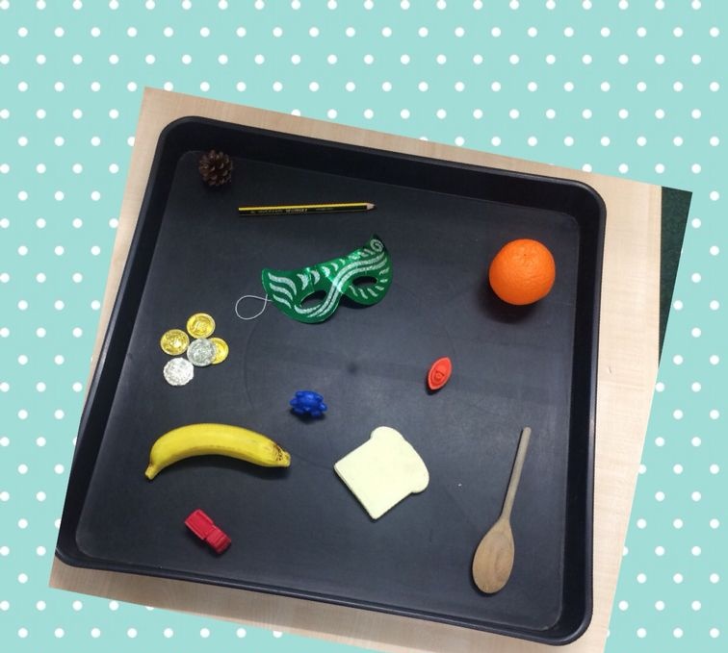
Rhyming games:  - Rhyming pairs - Use pictures or objects with names that rhyme. Take it in turns to turn over 2 cards and keep them if they are a rhyming pair  - Singing rhymes - Sing and say rhymes together regularly, make the game more active by inventing your own actions to go with the words. Spend time identifying rhyming words in everyday conversation with your child. | 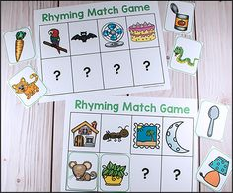
Alliteration:  - To the tune of “Polly put the kettle on...” Make up verses together to illustrate alliteration… Polly put the Pizza in… Simon sizzles sausages… | 
Rhythm:  - Can your child clap out the amount of syllables in different words?  - Can your child clap out the amount of syllables in their name? | 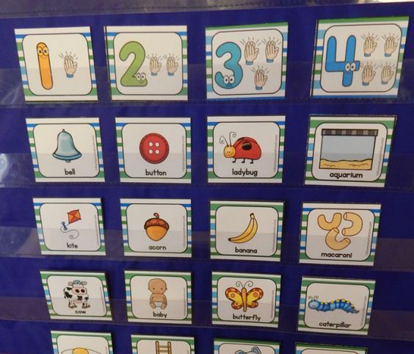
Stories and Poems:  - See if you child can join in with repeated phrases and words in traditional tales. | 

