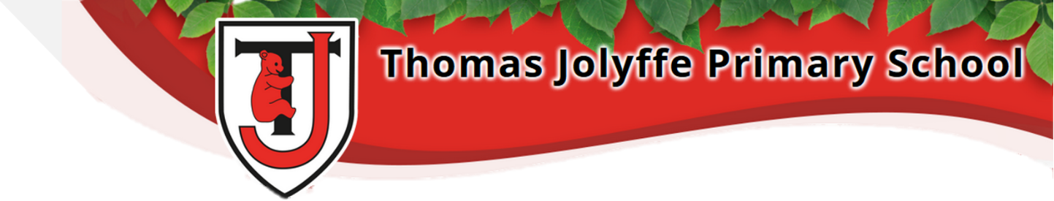
Year 2
Autumn 1

Dear Parents and Carers,
We hope you all had a wonderful summer and are as excited about the new term as we are! The following information is provided to support your child’s learning. However, if you have any questions or concerns, we have an open-door policy and so please feel free to come and speak to us.
Year 2 Team | P.E.
2WM – Mrs Wheatley and Mrs Musk  2F- Miss Fullerton  Learning Assistants – Mrs Beard, Mrs Mann, Miss Johnson | For the Autumn 1 half-term, both classes will have P.E. on Tuesday and Wednesday.  Please help to ensure that your child wears the appropriate clothing to school on these days. Earrings must be removed before the lesson.
Reading, Spellings and Homework | Topic
• A minimum of twenty minutes reading should take place every day. It is important that children have their reading book and reading record in school daily.  Reading books will be changed on different days each week  • We will be looking at place value to 100.  • English writing will include sentence punctuation, diary and narrative writing.  • Spellings will be set using our platform Spelling Shed. Log-on details will be sent out after October half term. There will be no spelling test but games and interactive activities to complete. Also, a written spelling activity will be set every Wednesday due in the following Wednesday.  • Though our spellings are initially linked to your child’s phonics understanding, as the year progresses, we will also be focusing on those exceptions - common exception words. A copy of these can be found attached.  Times tables:  Children will be introduced to multiplication later this academic year. At this point we will provide access details for our Times Tables Rockstars platform. Should your child wish to have their details sooner, please speak to your child’s class teacher. | Our first topic of Year 2 is Schools Past and Present.  In History, we’ll be finding out:  - How was school different in the past?  - How to identify historical similarities and differences using a range of sources.  In Science, we’ll be finding out:  - How to classify things as living, once alive and never alive.  - How to look for characteristics of life in plants and establish that plants are living things.  In Art and Design, we’ll be finding out:  - How to develop cutting, threading, joining and folding through fun creative arts projects.  In Computing, we’ll be finding out:  - How to be safe online and coding.  In PSHE, we’ll be:  - reinforcing the Zones of Regulation to establish self-regulation and emotional control.  In Music, we’ll be finding out:  - That music has a pulse like a heartbeat.  Home learning information can be found on the reverse…
Thank you for your support this term,
Mrs Wheatley, Mrs Musk and Miss Fullerton

Home Learning
Each half-term we invite the children to get creative, undertake some research and learn some new skills by completing a home learning task linked to our current topic. Home learning projects will be shared in school during the final week of each half-term. We therefore ask that any completed projects are in school by 23/10/24.
Our current topic is Schools Past and Present, with a focus on understanding that although schools have been in the local area for a long time, they have not always been the same.
Below are some ideas to help your child get started
Ideas:
English:  - Produce an information leaflet  - Produce an informative poster  - Write a piece of non-fiction  - Create a set of instructions  - Write a story linked to the theme  - Create your own themed dictionary  - Write a diary | Mathematics:  - Find a timetable, calendar or schedule linked to the theme and talk about it  - Design a building using different 3D shapes
Computing:  - Find and app/ website and create a presentation | Art and D&T:  - Create a piece of themed artwork  - Create a 3D model
Science:  - Find out how science has adapted for the theme. | General:  - Visit a local area/ museum- take pictures!  - Research and create an interactive quiz or game

These are just ideas. You are encouraged to be original!



