
COMPUTING: CREATING MEDIA- Digital Photography
KNOWLEDGE ORGANISER
Y2

Overview |  |  | Editing Techniques
  Digital Photography  -We can use digital devices to help us to take and edit photographs.  -Many different devices can be used to take photographs, for example digital cameras, phones, tablets and webcams.  -We can also use lots of different apps and programs to edit and improve photos, for example Photoshop, Luminar and Pixlr.  -We should understand the not all photographs that we see are real – they may have been edited. |  |  | Editing is when we add, change and remove things to get the result that we want. Many things can be edited in photographs to create different effects.
 |  |  | 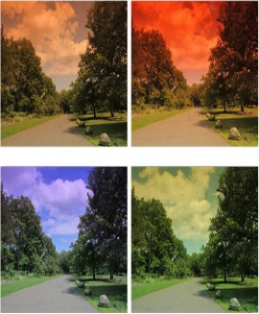  Photograph editing programs often have filters. These can change the colours in a photograph. Different colours can give us different feelings. | 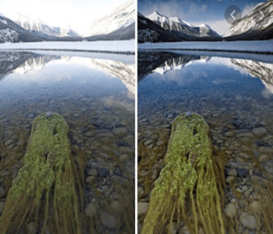  You can also change the contrast of a photograph. This can make the subjects become clearer or more blurry.
 |  |  | When the lighting of the photograph is not quite right, we can change the brightness of the photograph.  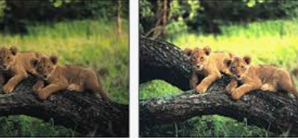 | 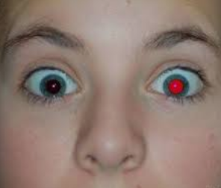  There are features that we can add or remove from the photograph whilst editing. E.g. removing red eyes.
Taking Photographs |  |  |     When we want to save our edit, we should click on the ‘save’ button. The first time, we need to choose a file name and a location (folder) to save it in.  If we are using an iPad, we can retrieve our images from the camera roll.
Photography is a way of making a picture using a camera.

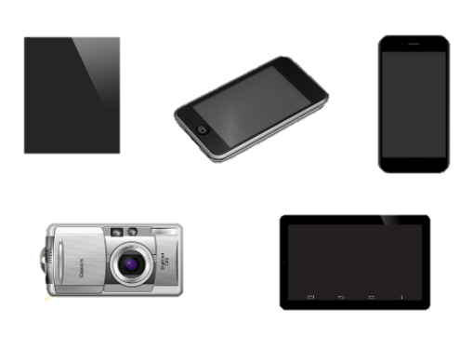  -There are lots of different photography devices (things that we can take photographs on).  e.g. smartphones, digital cameras and tablets.  -There are also lots of different subjects we can take photos of: e.g. a selfie, an action shot, or a beautiful scene. |  |  | Real or Edited?

-There are lots of different ways that images can be changed. Sometimes it is hard to tell whether a photograph is real or has been changed.
-The software for editing photographs is becoming better, and people are getting more skilled at using it.
-People may change a photograph to make it look as though it is real, but in fact it is edited
-They may do this to try and advertise a product or present something in a different way. Do not always believe what you see!

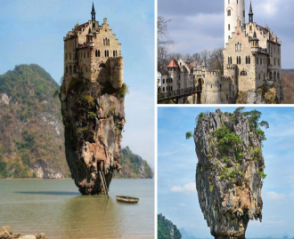

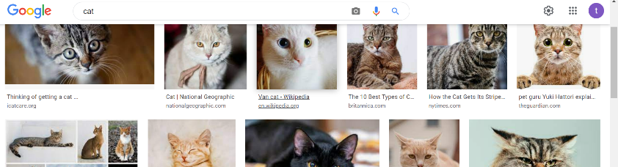
If we are looking at photographs on a website, we can use the scrollbar to move the page up and down.

Choose landscape or portrait.
How to take a photograph
- Hold the device firmly with both hands
- Point the camera at the subject.
- Look at the viewing screen.
- Move the device to get the shot that you want.
- Press the capture button.

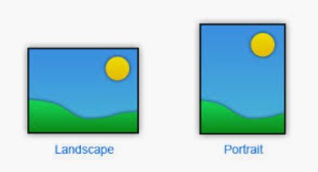

Important Vocabulary

Device Capture Image Digital Landscape Portrait Filed of view Narrow Wide Format Framing Focal point Subject natter Compose Natura/artificial lighting Flash Focus Background/foreground Editing Tools Filter Changed Real

