
COMPUTING: PROGRAMMING- Moving a Robot
KNOWLEDGE ORGANISER
Y1

Overview |  |  | Buttons and Programs
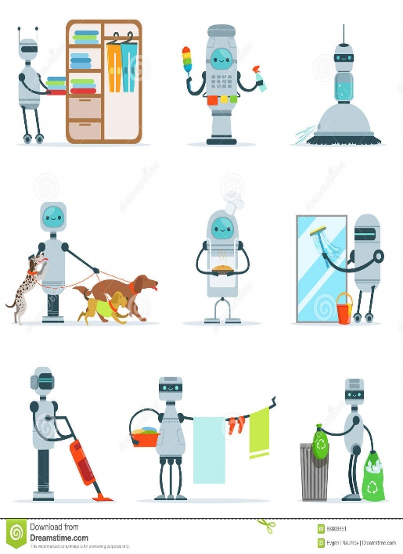  Moving a Robot  - Programming is when we make a set of instructions for computers to follow.  -Robots are one type of machine that can follow programs. Floor robots include Bee-bots and Blue-bots.  -Floor robots have buttons which help us to direct them. We can use algorithms (a set of instructions to perform a task) to program floor robots along routes. |  |  | 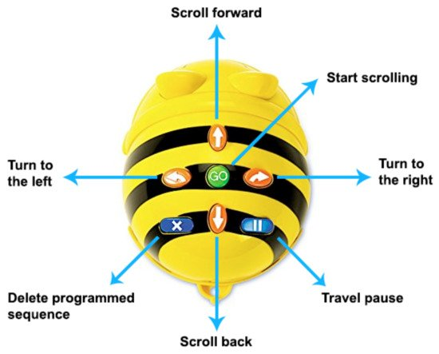  -Buttons: Bee-bots have buttons on the top. They each make the Beebot do something different (see picture).  -The arrows move the Bee-bot in different directions.  -The GO button makes the Bee-bot start its program. (on some models, it also pauses the Beebot in-program).  -Programs: A program is a series of instructions. We can program the Bee-bot by pressing the direction buttons (in order) that we want it to move in, followed by GO.  -The X button makes the Bee-bot delete the program and make a new program. Switching the Bee-bot off and on again also deletes the program.  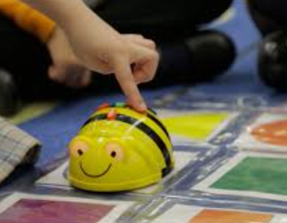
Robots and Floor Robots
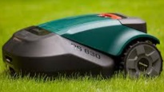
-Robots: Robots are machines that we can program to do human jobs.


-Robots help us to do things, for example to help us clean, mow and learn!

-Robots in factories make things, and in hospitals they help make us better.
 |  |  | Directions | Routes and Algorithms
 |  |  | -In order create clear routes for our Bee-bots, we need to be sure of our directions.  Forward  Right  Left  Backward  Make sure that you stand behind Bee-bot. |   -A route is the course that we travel to get somewhere. We use algorithms (a set of guidelines to complete a task) to program our floor robot to take a route to where we want it to go.  -We should think carefully about how to avoid obstacles. We should also consider how many times we need to press each button to travel the correct distance.
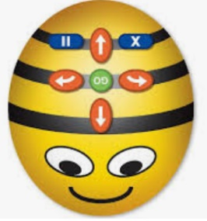  -Bee-bots: Bee-bots are a type of floor robot.  -We can programme Bee-bots to move around.  Bee-bots should only be used on the floor, and not tables etc. They can be damaged if they fall from high surfaces. |   -Turning on a Bee-bot: Before we use a Beebot, we need to make sure it is charged.  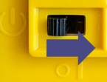  To turn it on, using the switch underneath. You can tell that the Bee-bot is on because its eyes light up. Switch it back off again after you have finished using it.
Important Vocabulary

Bee-bot forwards backwards turn clear go commands instructions directions plan algorithm program route

