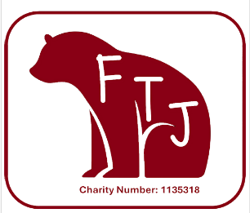
FTJ Newsletter

We are super busy planning our next round of events at Thomas Jolyffe.
I would like to start this newsletter by introducing the core FTJ team behind all the planning and running of events….
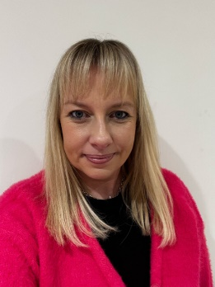



Carly Kennedy
Treasurer
2 children in year 2&6

Rachel Preedy
Co Chair
2 children in year 1&5

Lisa Loughlin
Co Chair
1 child in year 2

Claire Hopkins
Deputy Secretary
2 children in year 2&4

Charlie Careless
Secretary
1 child in year 2




Kate Mitchell
Deputy Chair
1 child in year 6

We also have many other volunteers who help behind the scenes organising Christmas Decoration sales, helping at all events and supporting with background planning and prepping.
Please feel free to chat to us in the playground if you have any ideas, questions or would like to be involved.
We have a parent questionnaire coming out today and would appreciate any feedback and suggestions for FTJ to use in their future planning.
Coming up!
This half term we have two events in the pipeline, kicking off with our World Book Day Wonka bar sales. These are now for sale on parent pay for £2.50 and will be handed out to children on WBD. Will your child win a golden ticket prize?
Sponsored Colour Run
We are so excited for this brand-new event to happen at TJ. This will be our first sponsored colour run, and we can’t wait for this event!
If you have not heard about colour run events, then please check out www.ukschoolrun.com. This is the company we shall be using to supply our powder paint. Their website shares details of ingredients and a sample risk assessment which we shall be adapting to fit our school.
The colour run will take place on Friday 11th April in the afternoon across the two fields. Children will run in class groups and there will be adult run stations where children will have powder paint thrown at them (and weather permitting water guns). The field will be transformed into an exciting obstacle and children will be cheering on and supporting other year groups.
The cost to enter your child into the colour run will be £2.50 and payable via parent pay along with a permission form to be completed. Children will come home with sponsor forms in the run up to the event, where they can tell friends and family all about this exciting event and ask for sponsorship for their run. Lasts years sponsored event was such a roaring success with over £2000 raised and we would love to beat that this year!
Children will be required to wear a white t shirt and old bottoms. If your child would like to wear their swimming goggles for the event, then this is also advised.
We are still looking for volunteers to help run this event, please contact FTJ if you would like to support at this event.
We would also love to hear from any parent photographers who would like to come and take photos of the event. It would be fabulous to have several photographs at different stations to capture the laughter and fun of the event. If you would like to be involved, please contact FTJ or have a chat with one of us in the playground.
Silent Disco
Thursday 22nd May we shall be holding our first silent disco! We are really looking forward to providing children with this new and exciting experience!
Non School Uniform Day
Date to be confirmed after Easter. This day will be in exchange for donations towards our stalls for the summer event
Circus
Thursday 3rd July we will be holding our summer event, the circus!! We will have two shows running in the early evening with more information to follow over the next half term. Keep your eyes peeled for early bird tickets.

Other news…
Last term we raised just over £1000 through our tombola, disco and drinks sales. Thank you to all those who took part in the events.
FTJ have some exciting new projects on the horizon now that we have completed fundraising for our new outdoor play equipment (currently being installed) we would like to share our next plans…..
Subject/ Topic Boxes
FTJ are currently supporting subject lead teachers in updating their 11 subjects and topic boxes to benefit all year groups.
New permanent disco lights will be installed in the hall for future discos.
Each year group will be provided with funds to plan an FTJ FUN DAY during the summer term. This will be planned by the children and teachers to say Thank you for all your support towards FTJ events and raising funds for the school.
Please complete this short survey to help us to continue to grow as a team and support all the children at TJ
https://forms.office.com/e/R0YejP3wmb

